- Created an app N26 in order to easily navigate through the case study.

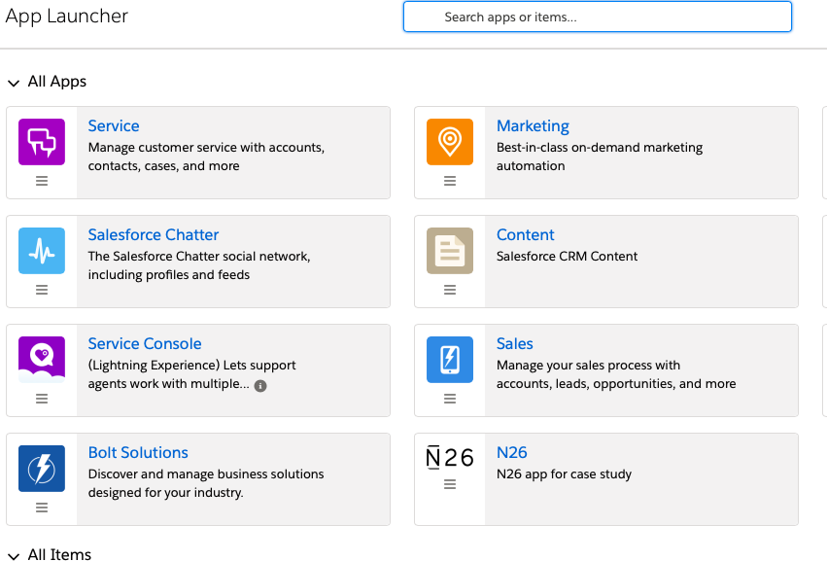

- N26 app mainly consists of Home, Accounts, Contacts, Products, Product Inventories and cases objects.

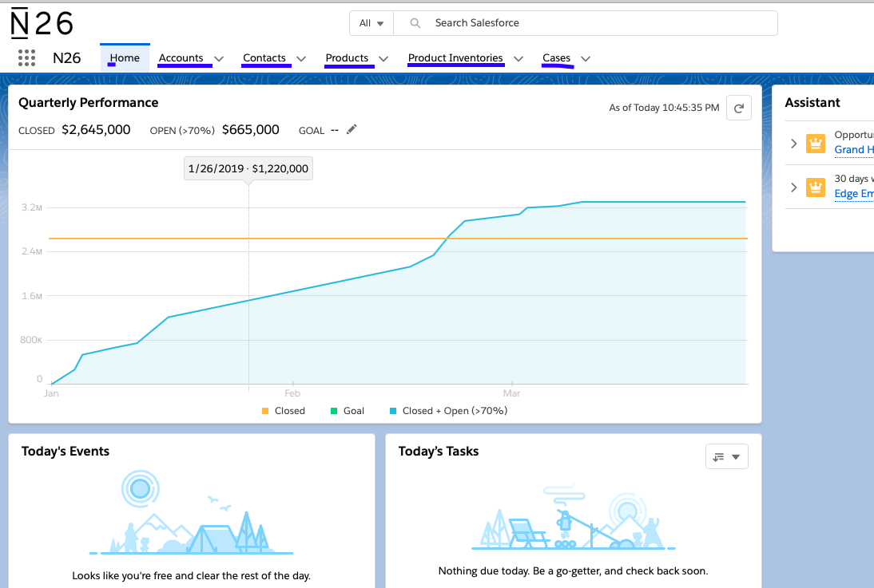

- Contact consists of 3 fields, Home Country, Product, Language created for case study.

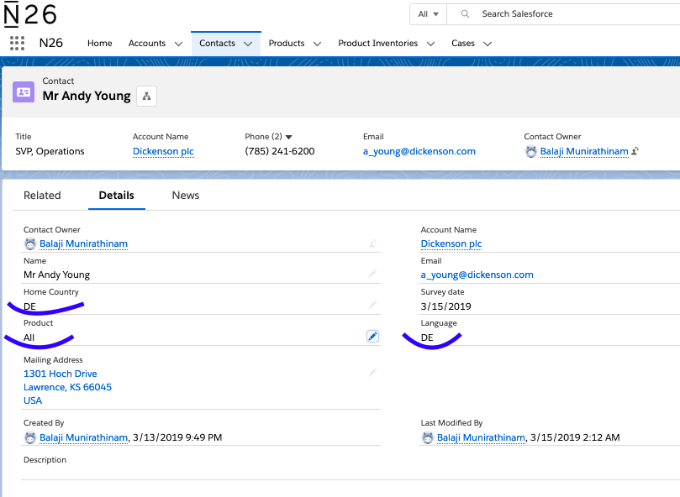

Home country field is a picklist with values: DE, FR, ES, IT and UK.
Product field is a picklist with values: ALL, Standard, Metal and Black. On selection of ALL all 3 products will be displayed and respective single product on selection of Standard, Metal or Black.
Language is a field with picklist values : DE and EN just for now.

We can change the product picklist on Contact accordingly to display different type of products to be displayed on the case layout and additionally on the contact details via product details button.

- Contact consists of related lists – Product Inventories a junction object to link CONTACTS and PRODUCTS.

NOTE: Out of interest I created additional button – Product details on contact object to display the same products used by the contact. Please check it too.

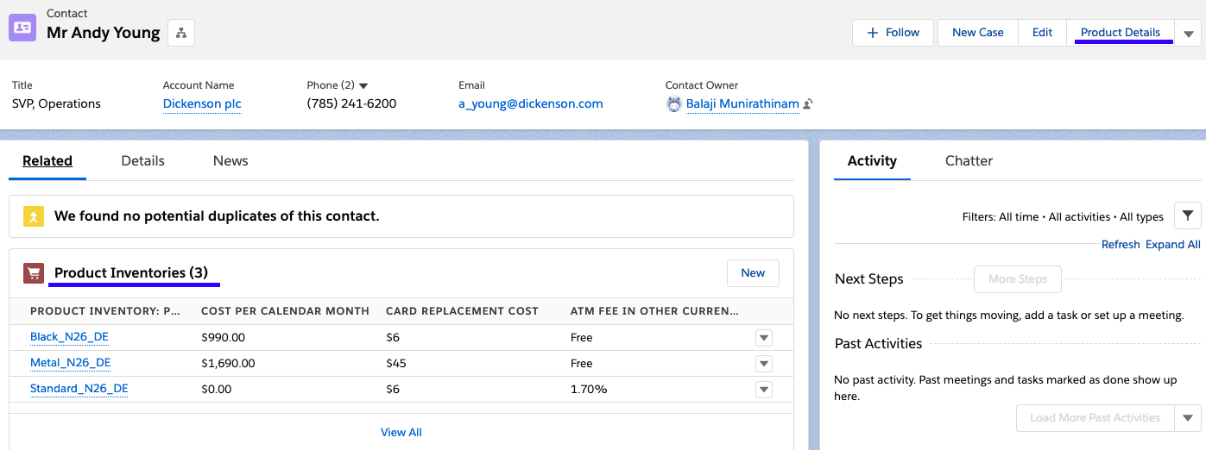

- Products are separate objects with fields displayed as shown in below screen shot.

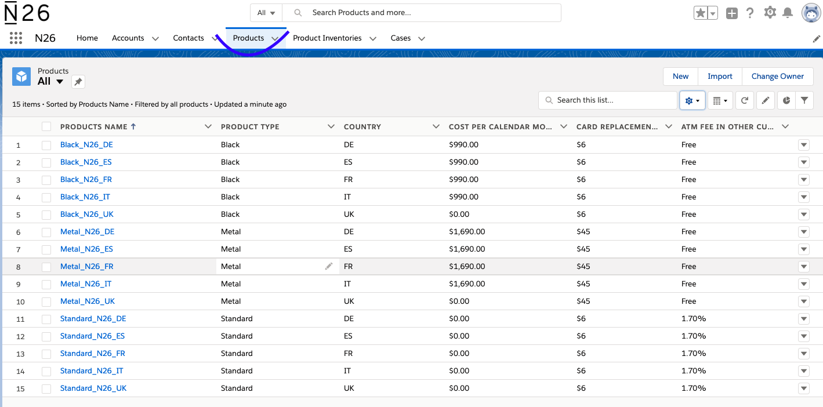

- Cases are standard object and products are displayed on the right side of the screen as highlighted with scroll bar.

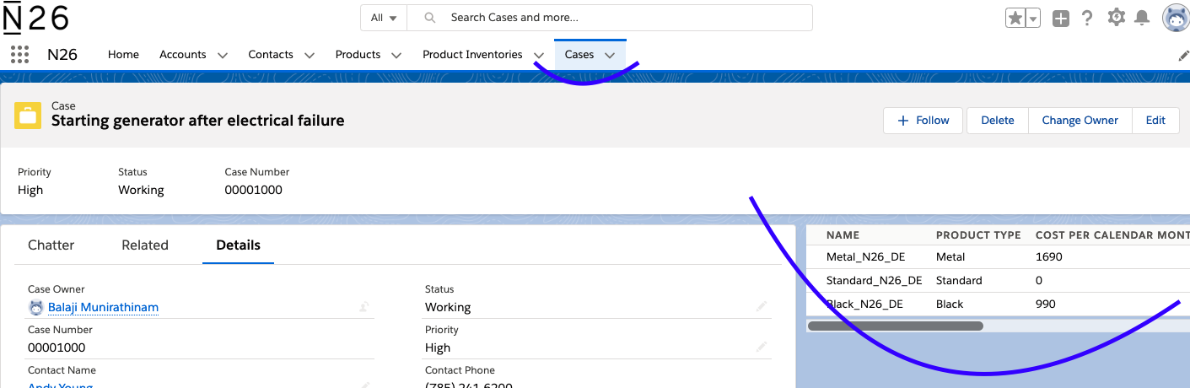

- Product Inventories are junction object with master detail on Contact and Products as shown in below screen shot.

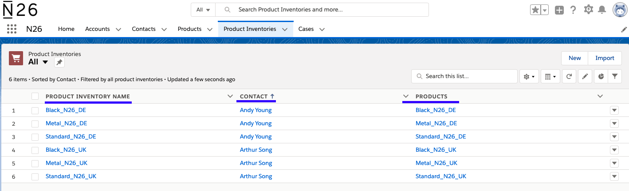

Junction object helps products to act as standalone object so that products can be modified anytime in future and we can just remove the junction object link from contacts.

Junction object also helps us to reuse the same products to multiple contacts making it loosely coupled and notbeing restricted to just one product.

